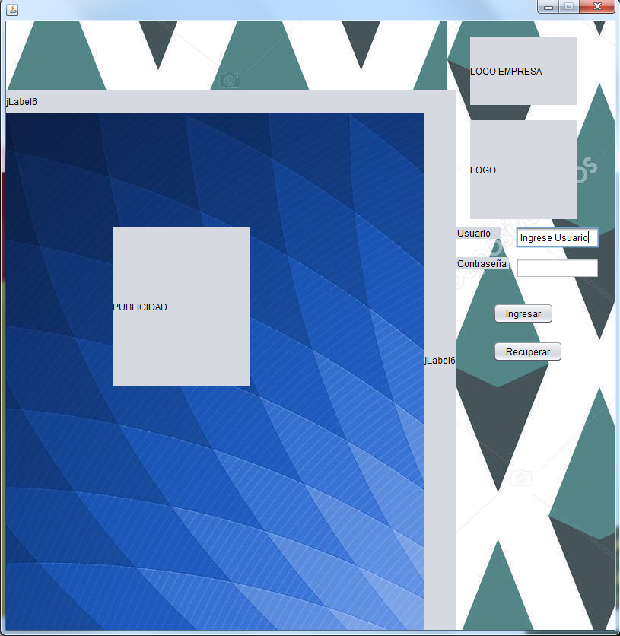

Componentes

1. Logo de empresa
2. Logo
3. TextField
4. Password Field
5. Boton1
6. Boton2
7. Label
8. jLabel
9. jLabel